TASK 1

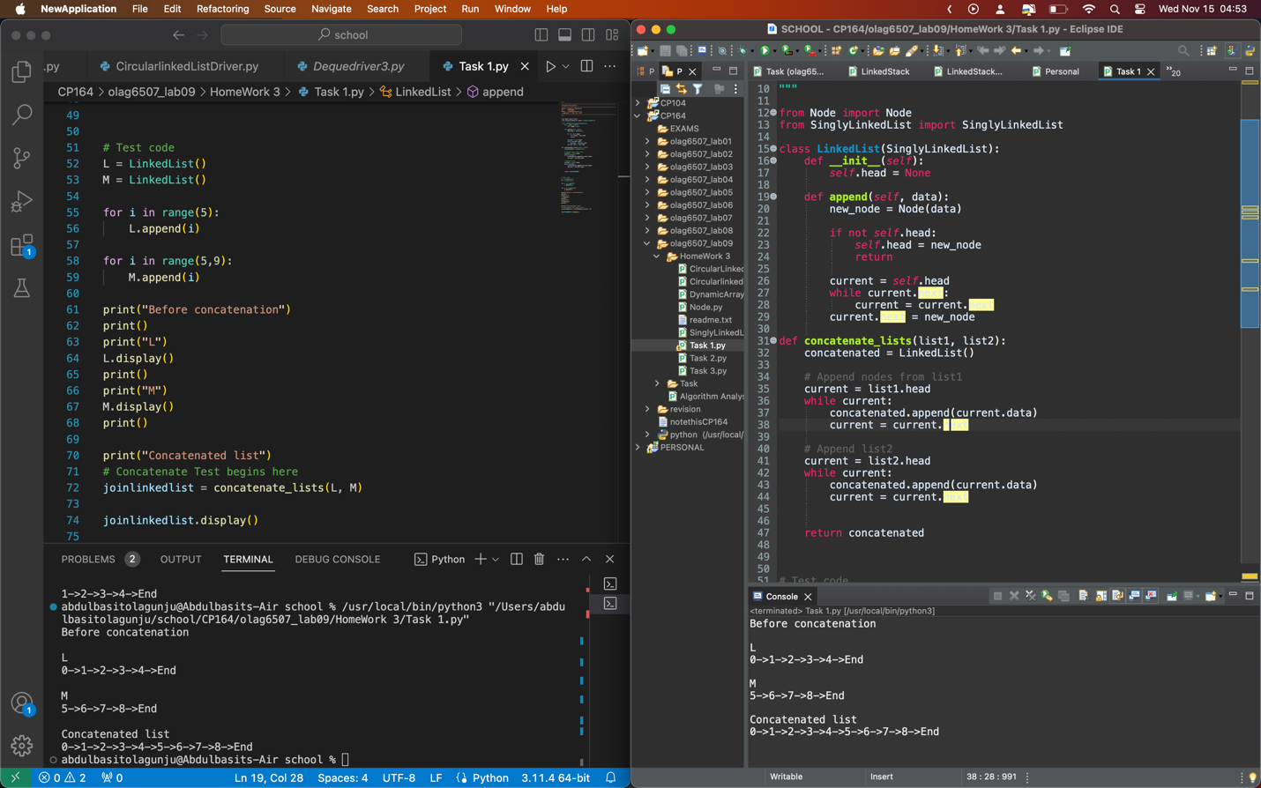

TASK 2

TASK 4

